**Practical 9**

**Aim**: Configure a Network using Distance Vector/Link State Routing protocol.

**Distance Vector:**

* Distance Vector is classful Routing protocol
* Periodic updates of the full routing table are sent to routing neighbors.
* Distance vector routing protocol is used Bellman-Ford algorithm.
* Distance vector routing protocol begins by advertising directly connected networks to its neighbors. (RIP – every 30 seconds; IGRP – every 90 seconds)
* Distance – vector protocols utilize some form of distance to calculate a rote’s metric.

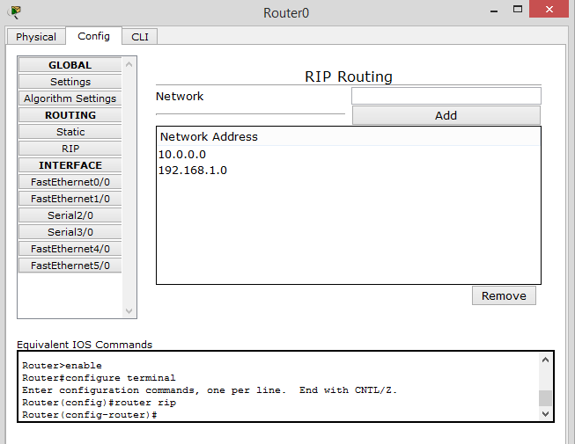

Fig9.1 Configuring RIP routing router 0

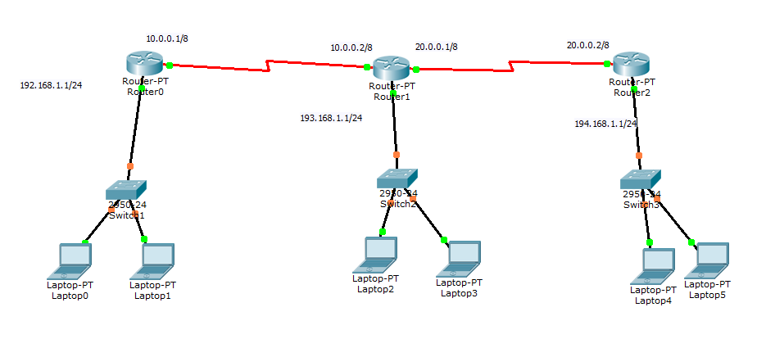

**Fig**9.2 Network stabilize through RIP routing

**Link State Routing:**

* Classless routing protocol
* Support for VLSM
* Connection Oriented protocol
* Trigger update support
* Link state routing protocol is used Dijkstra algorithm
* Link state routing protocol maintain 3 separate tables.

A. Neighbor Table

B. Topology Table

C. Routing Table

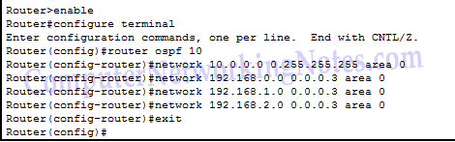

Fig 9.3 Configuring Router with Link State Routing Protocol(OSPF)

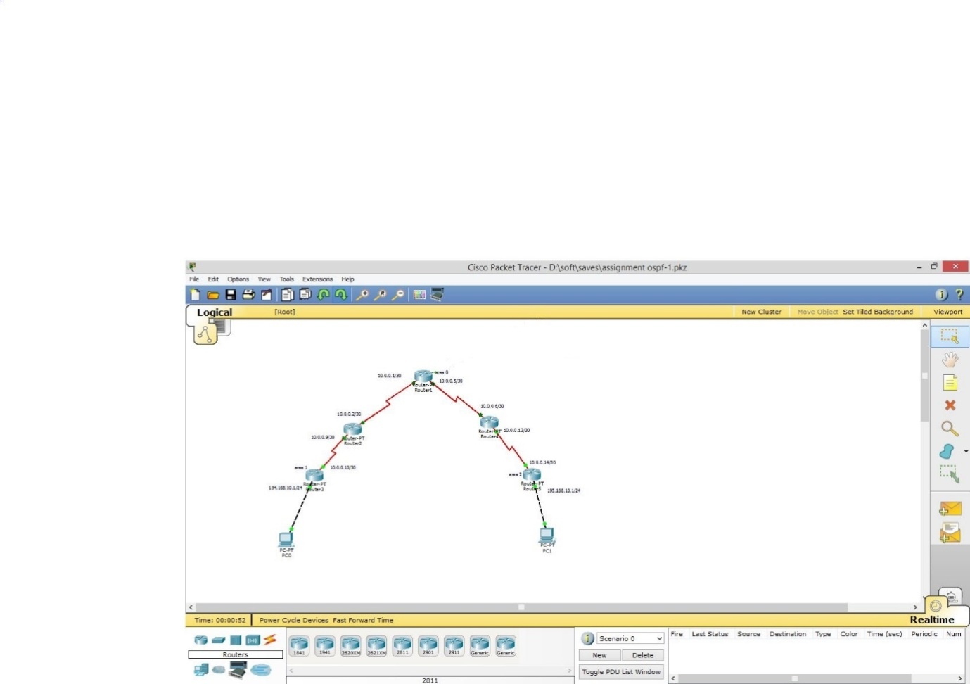

Fig 9.4 Network Stabilised with Link State Router